FACTS – 07-2012

The following facts have been collected from the following sources: Quotes from Peter Lindberg and Dennis Asberg, and various news sources - see below links. (It is possible that some portions have also been taken from various other reputable websites. If there are any discrepancies, they should be listed in the comments section.)

- Lies at approx. 90 meter depth in international waters between Sweden & Finland
- Perfectly round object made of a "rock-like" substance.
- Perfect dome shape.
- It has rounded sides with rugged edges (not smooth). "It's like someone has pinched the mountain at the edge, as if you have moulded together two molds, and it sticks out stones between the molds", said Stefan Hogeborn." (taken from article on Expressen.se)
- There is a wedge formed gap between the upper part (the circle) and the lower part (foundation/pillar). However, if the two parts are completely separated or if the upper part and the lower part are the same object has not been clarified“ See image: 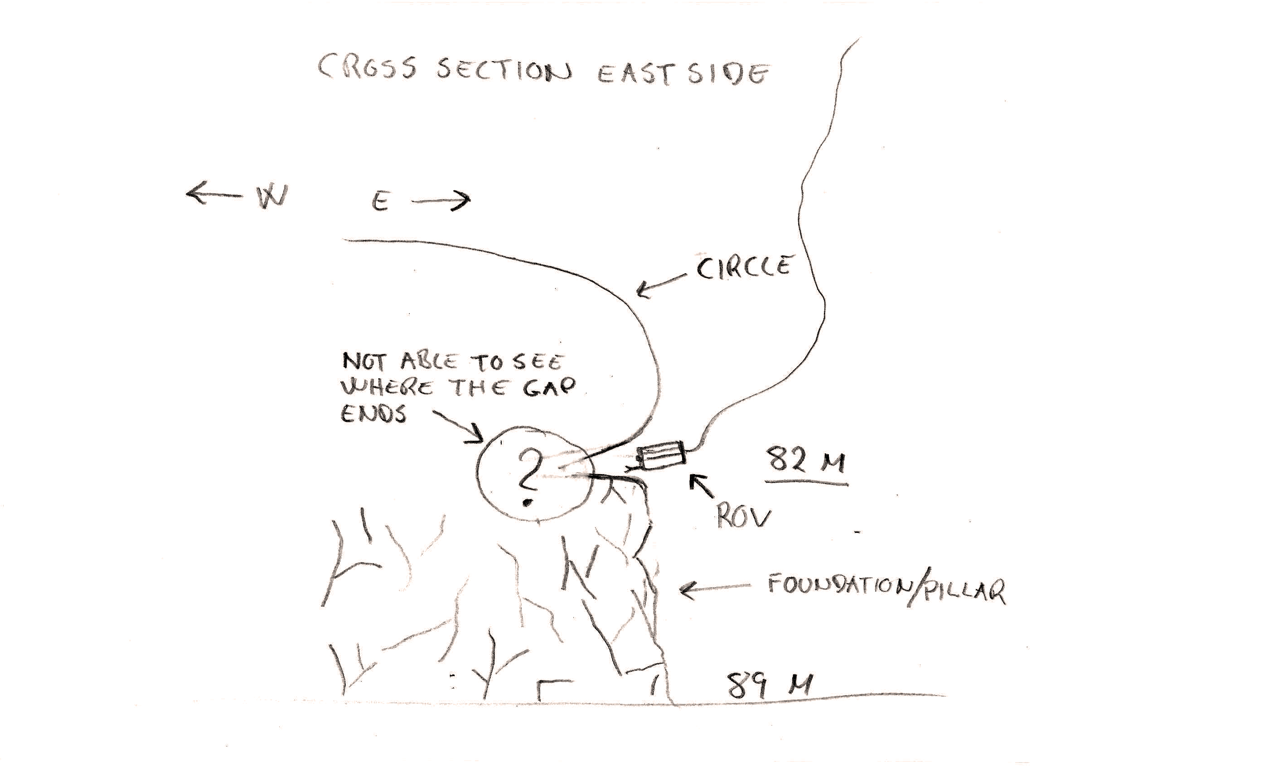
- 200ft in Diameter. (60 meter)
- The object seems to be very very old, rare and something the crew has never seen before. (Peter Lindberg feels that it could be Pre-ice age.)
- The surface has cracks on it. There is some unidentifiable black material in the cracks
- 12m tall = 4 meter thick 60 m circular object supported on 8 m pillar (increases in thickness at top near the object)
- On one side of circle it's protruding approximately 4-6 meters from pillar
- circle is NOT connected to pillar, it separated. Looks like granite, surface of anomaly is made of different material than pillar.
- Looks like something has been very hot down there so that the stone has melted. Burnt-looking stones covered in a black film/soot on top of and surrounding object. A normal stone from the surrounding area, which has burnt magma on it, was taken as a sample for analysis at Stockholm University
- Dennis said that a volcano is possible, however according to researchers, there has never been a volcano there. A volcano does not look like what they've found because of the perfect form of it also because of the 90 degree angles
- Lying on top of the object are strange circular rock formations, like "fireplaces", of hard black "almost petrified" burnt looking stone each a few inches in diameter, like 4 or 5 pearls in a necklace. These stones are covered in something resembling soot.
- Divers said there was a "blackish" powder that had been attracted to the cameras.
- There are other, loose stones lying around as well
- Many 90 degree angles and straight lines: .5 - 1.5 meter high corridors within object. They appear to be like passages or walls approx. 1.5 meters in height and 3 meter wide, which are cut into the object. The walls are straight and smooth.They are made of stone resembling sandstone.
- Has a circular dome shaped "Meringue" formation, approx. 27 feet in diameter and 5 feet at the highest point., which sits directly on top of the 60 meter rock formation. The meringue is located on edge on the right side of sonar scan. It appears to be covered in some type of hard cement-like substance, mineral deposit. Surface not entirely smooth, some places the "cement" is cracking.the rock isn’t covered at all in silt, which should have typically occurred on the bottom of the sea. It appears to have construction lines and boxes drawn on it. After being chipped, the interior of object is black, like volcanic rock, almost petrified inside. Material is very hard, not simple stone, described as "preserved rock". Hogeborn describes the sense of carbonized material. In the center, it has an oblong hole (about 5.9 to 9.8 inches (25 cm) wide), going into it. It's not known yet where it leads. No additional holes were found.
- It looks like there is a stair-like structure off of the circular object, however this hasn't been confirmed. (Peter confirmed the "staircase" reference was only an example to describe what he saw and that it is comprised of 8 steps with each step a 1 meter drop starting from the missing section on the left.)
- There is a second anomaly which appears to have "gothic-like window shaped forms" which is located 200 meters away.
- 1500 meters (3800ft) trail leading to object that starts out shallow, and progressively gets deeper until it reaches a depth of 30ft at the base of the object.
- Lying approx. 2 kilometers from circular object is a "Volcano-Like Mountain". It is a 50 meter high mountain rising off the seabed in the form of a classic volcano. It has a "smoking" a cloud of undefinable material out of the top. Currently, there is no known volcanic activity in the Baltic region.
- NOT World War related
- Issues which may be of significance: 1) The satellite didn't work when the boat was directly over the object, but just some tenth meters away from position they worked again. 2) Electrical problems were experienced on the last expedition and also this time, but the team is not sure if its related to anomaly, as he said it is normal for him. 3) A strong radio signal of 40-50 megahertzwas picked up when they were near the object. Dennis said that it wasn't coming from the object. 4) Thermometer reading of -1 C at sea bottom, when it should have read +4 degrees C (this MAY or MAY NOT be relevant as the false reading could not be explained. It was thought to be a malfunction of equipment.)

News sources : http://newsfeedresearcher.com/data/articles_t25/object-team-baltic.html

http://www.zmescience.com/research/baltic-sea-ufo-mystery-solved-43243/http://www.welt.de/vermischtes/article106624328/Geheimnisvoller-Ostseefund-befluegelt-Ufo-Fantasien.html

Par Paul Woodthorpe et Laura Funke

Relayé par Yves Herbo pour SFH 08-2012

